Hardware - UD3
– Actividad 1 –
Placas bases
y características

Rubén Rey Feal - ASIR1
Índice:
Placa base: 3
Características Tecnicas: 4
Factor de forma (dimensiones) 4
Socket CPU (dimensiones y pines) 4
Bancos de memoria RAM (DIMM) 4
Componentes Compatibles con la Placa Base del Sistema de Procesamiento: 5
Microprocesador: 5
Con GPU integrada: 5
Sin GPU integrada: 5
Disipador con Ventilador: 5
Pasta Térmica de Alto Grado de Transmitancia de Temperatura: 6

Placa base:
Link Página Asus Placa TUF GAMINGB760-PLUS WIFI D4
https://www.asus.com/es/motherboards-components/motherboards/tuf-gaming/tuf-gaming-b760-plus-wifi-d4/
Manual Oficial Asus Usuario:
https://dlcdnets.asus.com/pub/ASUS/mb/LGA1700/TUF_GAMING_B760-PLUS_WIFI_D4/E21224_TUF_GAMING_B760-PLUS_WIFI_D4_UM_WEB.pdf?model=TUF%20GAMING%20B760-PLUS%20WIFI%20D4
Otros Manuales:
- PRIME PROART TUF GAMING INTEL 700 Series BIOS Manual ( English Edition )
- INTEL RAID Configuration Guide ( English Edition )
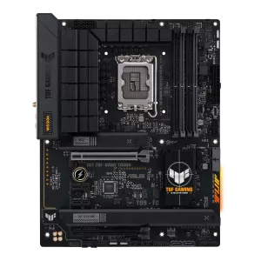

Características Tecnicas:

Factor de forma (dimensiones)
ATX Form Factor 12 inch x 9.6 inch ( 30.5 cm x 24.4 cm )

Socket CPU (dimensiones y pines)
Intel® Socket LGA1700 for 13th Gen Intel® Core™ & 12th Gen Intel® Core™, Pentium® Gold and Celeron® Processors*
Supports Intel® Turbo Boost Technology 2.0 and Intel® Turbo Boost Max Technology 3.0**
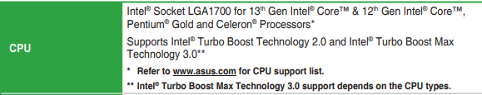

Bancos de memoria RAM (DIMM)
4 x DIMM, Max. 128GB, DDR4 Non-ECC, Un-buffered Memory* Dual Channel Memory Architecture
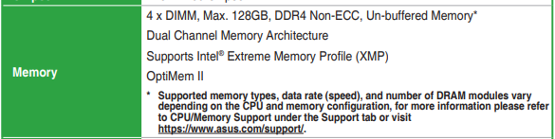

Componentes Compatibles con la Placa Base del Sistema de Procesamiento:

Microprocesador:

Con GPU integrada:
Link: https://www.pccomponentes.com/intel-core-i9-13900k-3-ghz-box
Intel Core i9-13900K

Sin GPU integrada:
Link: https://www.pccomponentes.com/intel-core-i5-13400f-25-ghz-46-ghz?campaigntype=pmax&campaignname=pmaxOfertastop&gad_source=1&gclid=EAIaIQobChMIicfn4NncggMVhU5BAh1SOwx1EAQYAyABEgKJWvD_BwE
Intel Core i5-13400F 2.5 GHz/4.6 GHz

Disipador con Ventilador:
Link: https://www.pccomponentes.com/cooler-master-hyper-212-led-turbo-argb-ventilador-cpu?campaigntype=eshopping&campaignchannel=shopping&gad_source=1&gclid=EAIaIQobChMIjaHm4tzcggMV8IRoCR1rZQv1EAQYASABEgJCtfD_BwE
Cooler Master Hyper 212 LED Turbo ARGB Ventilador CPU
Manual link: https://manuals.plus/m/826c7f6c282b0028977aff45be304d363bf164cfcd2d8108c22221b3bbe7d524_optim.pdf
Sistema de atornillado:
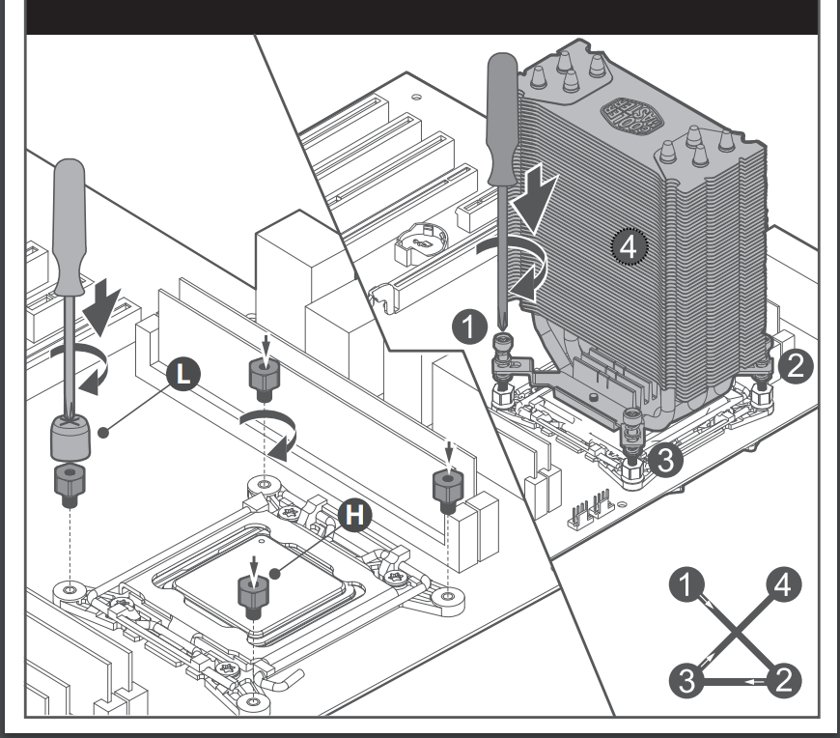

Pasta Térmica de Alto Grado de Transmitancia de Temperatura:
Link: https://www.pccomponentes.com/forgeon-lichborne-pasta-termica-4g-135w-mk
Forgeon Lichborne Pasta Térmica 4g 13.5W/mK
